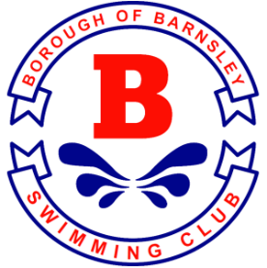
BOROUGH OF BARNSLEY SWIM CLUB
CHRISTMAS SPRINT 2021 - PAYMENT SUMMARY

Club ___________________________________

Number of Girls Entries ______________

Number of Boys Entries ______________

Total Entries @ £6.50 ______________

Number of Coach passes ______________

Cost coach passes @£15.00 ______________

Total Payment to be made by BACS / Cheque

_______________

